Supplementary Figures

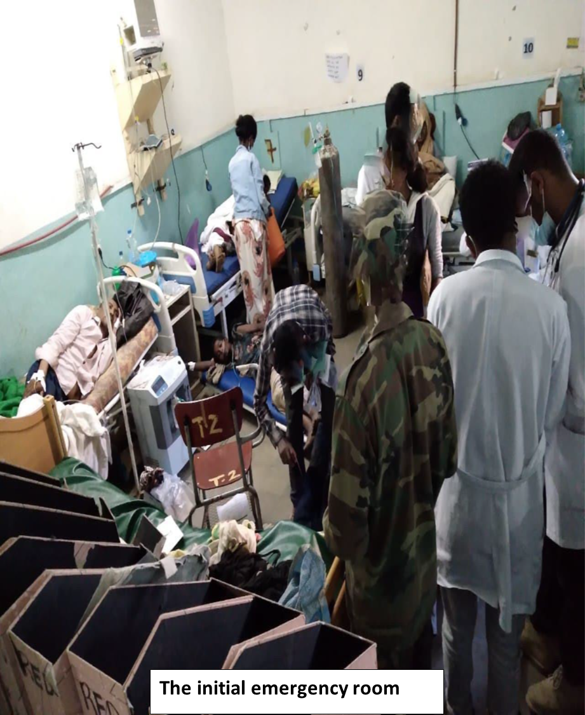
Figure 1 shows the initial emergency service area

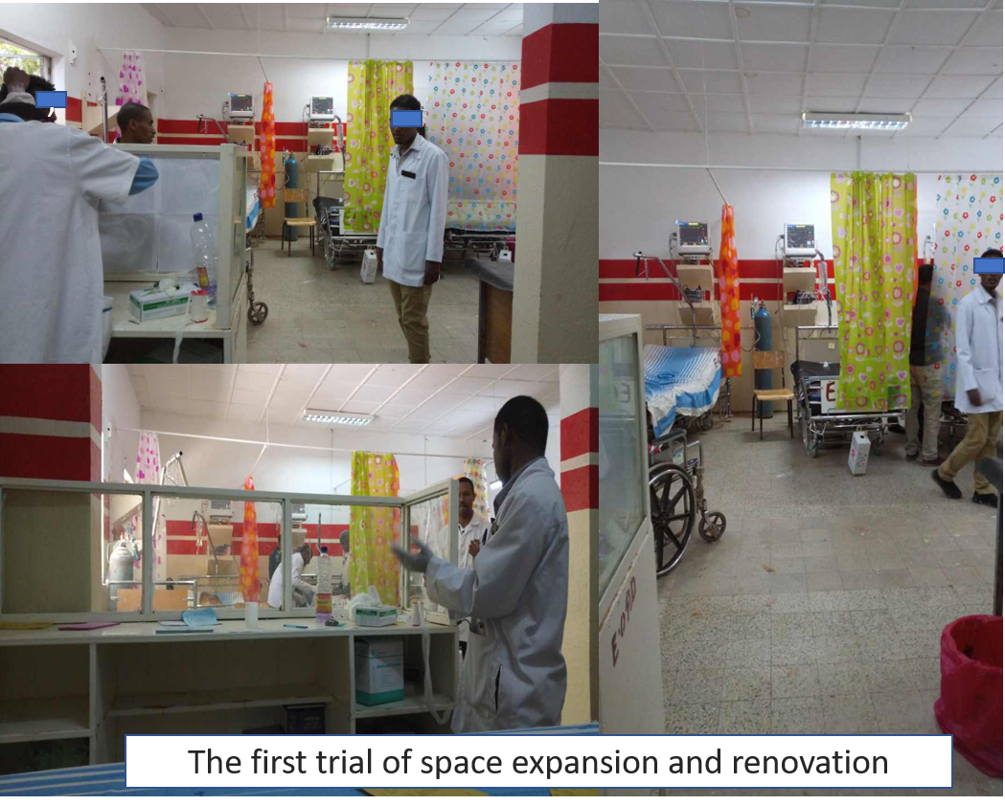
Figure 2 shows the first trial of space expansion and system establishment
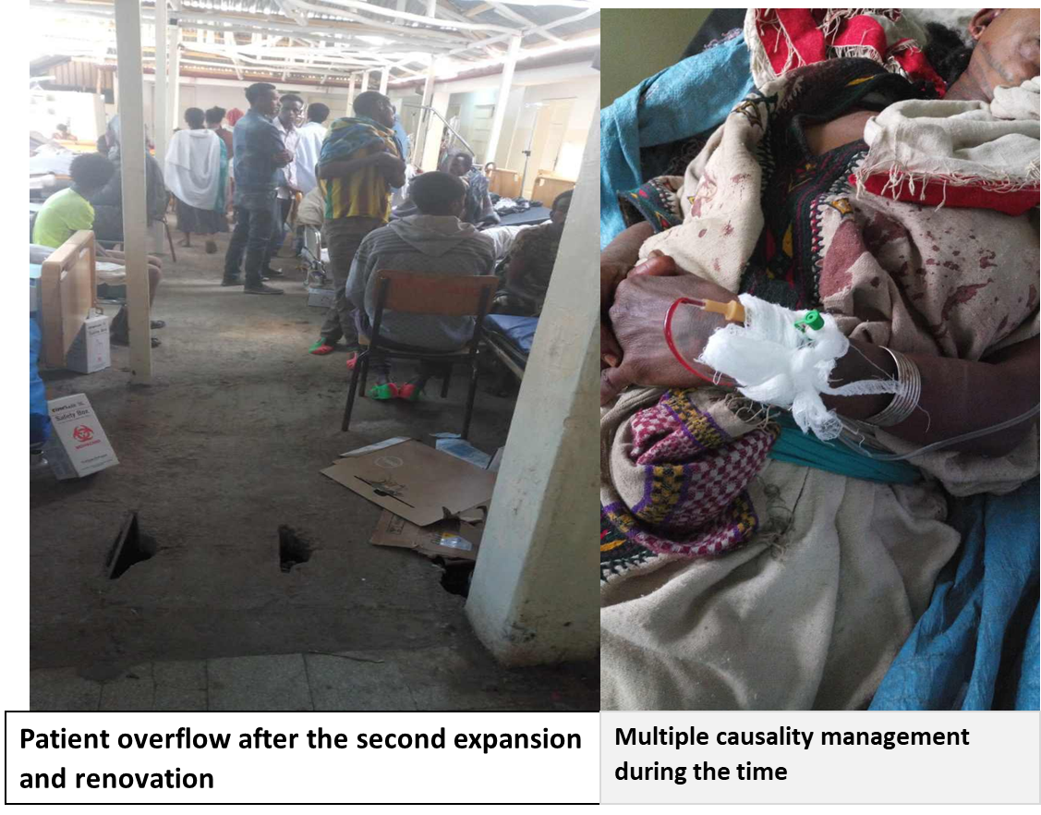 Figure 3 patient over crowding after the first expansion and ineffective case management

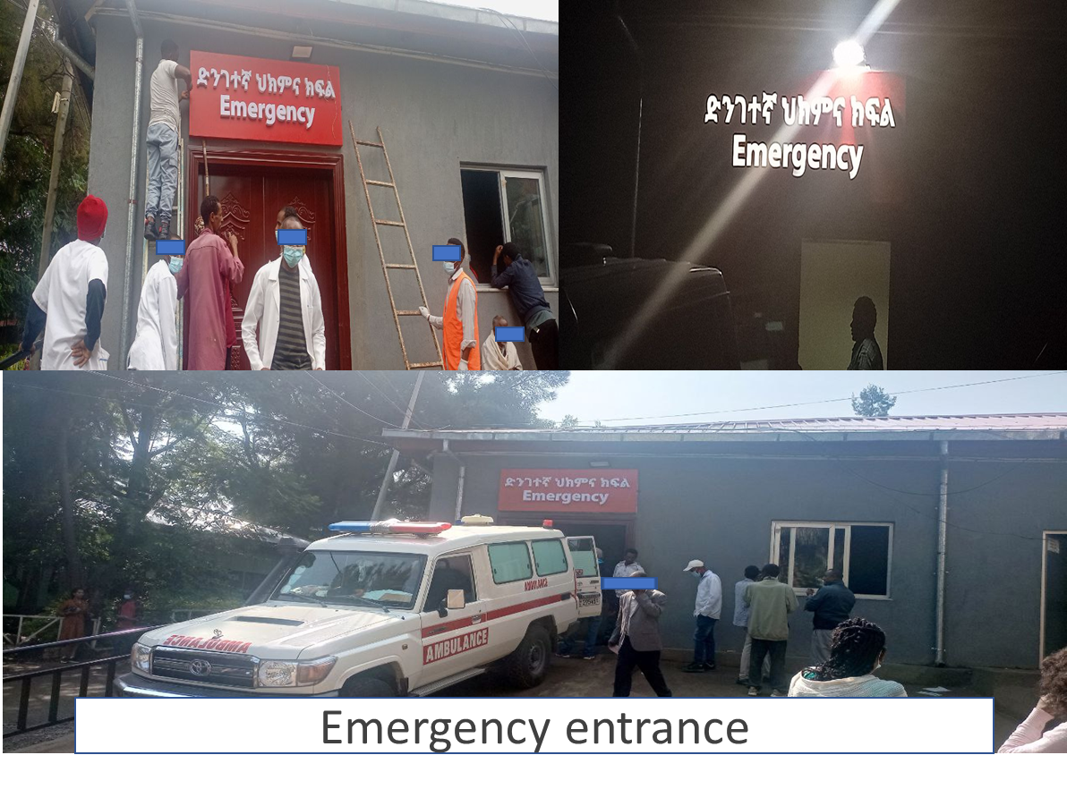
Figure 4 emergency entrance after the second renovation and system redesign

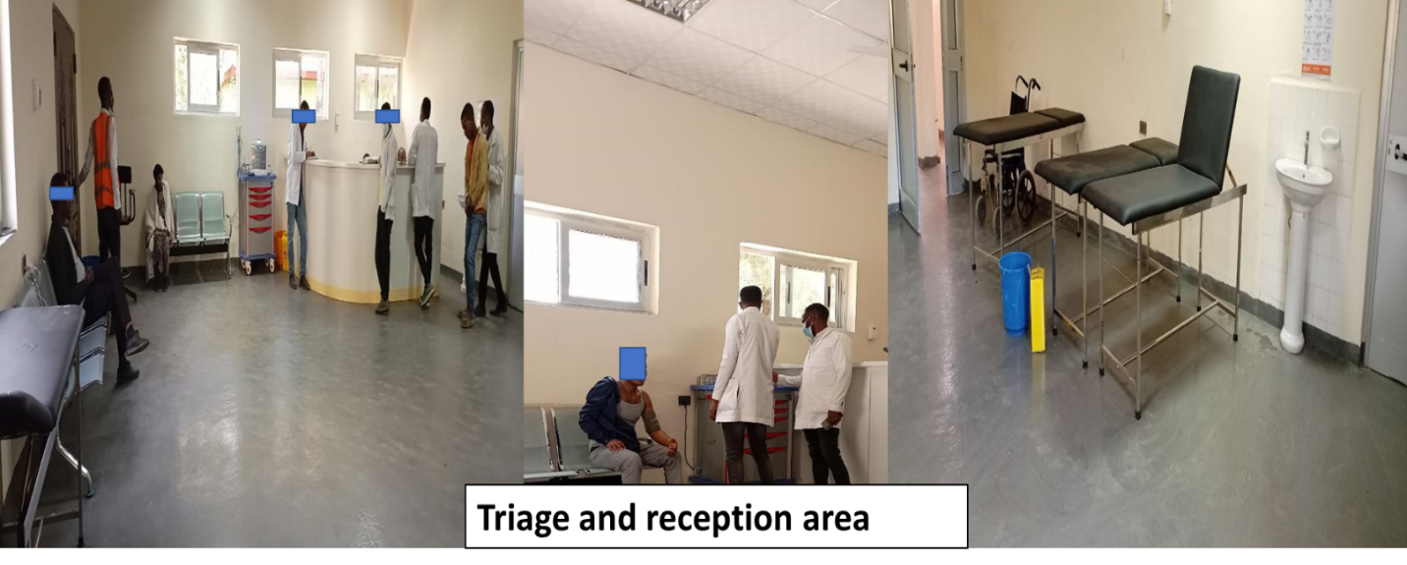
Figure 5 triage and reception area after the second renovation and system redesign

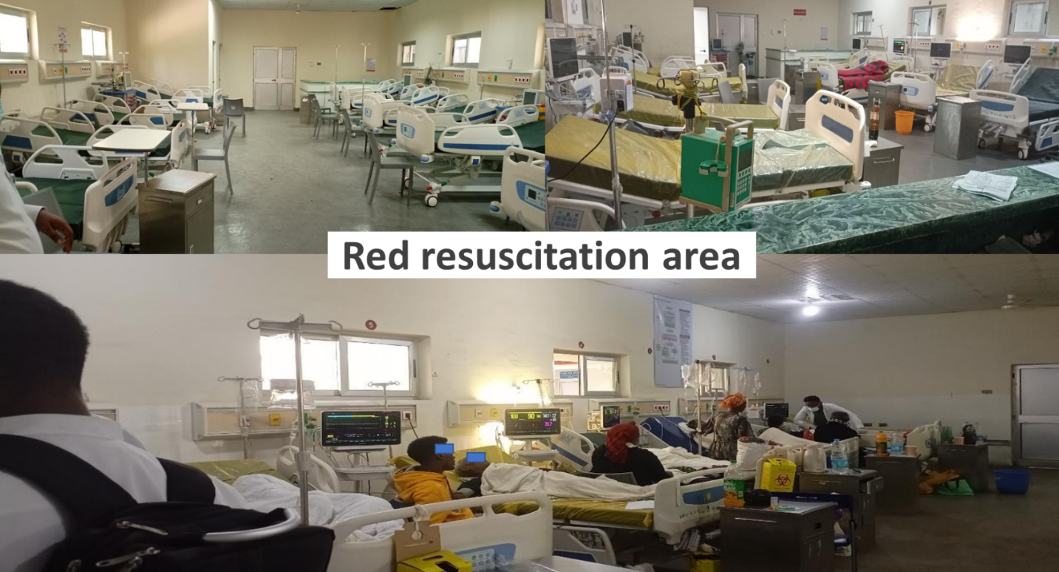
Figure 6 red area after the second renovation and system redesign

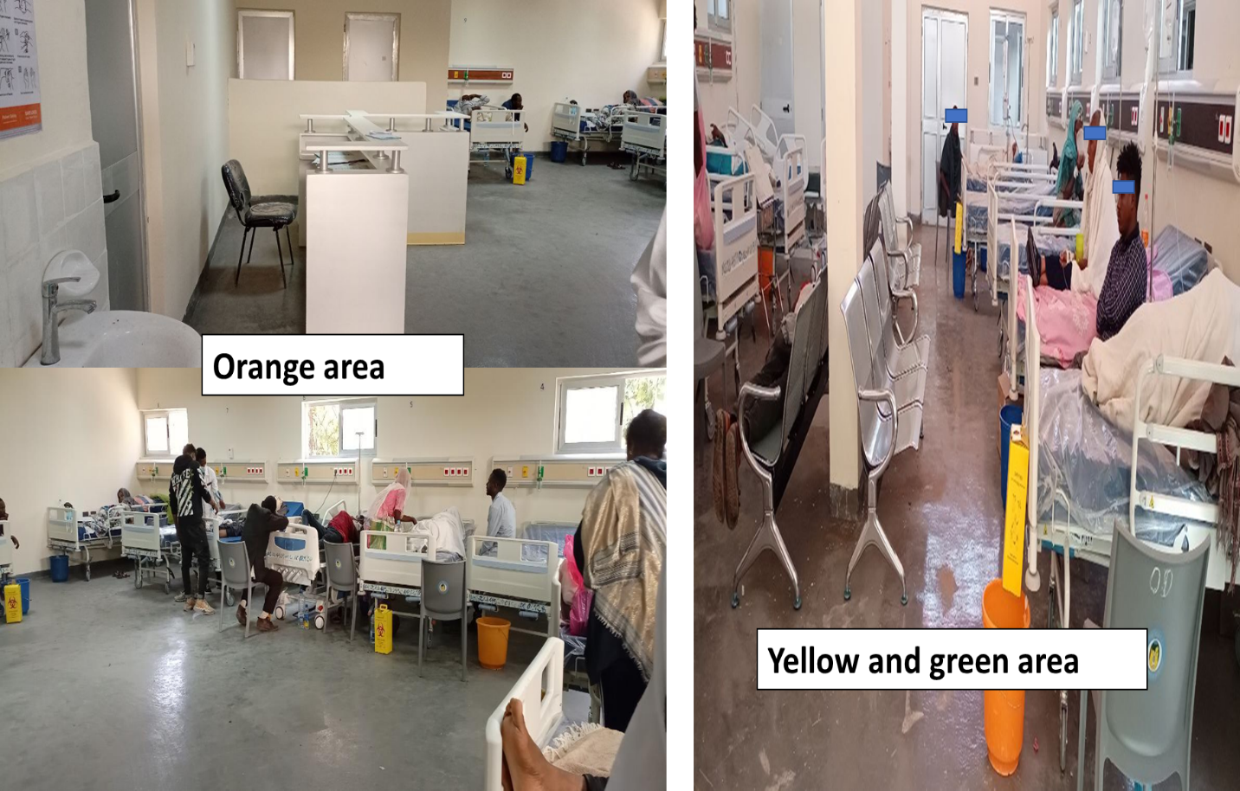
Figure 7 Orange and yellow green area after the second renovation and system redesign

