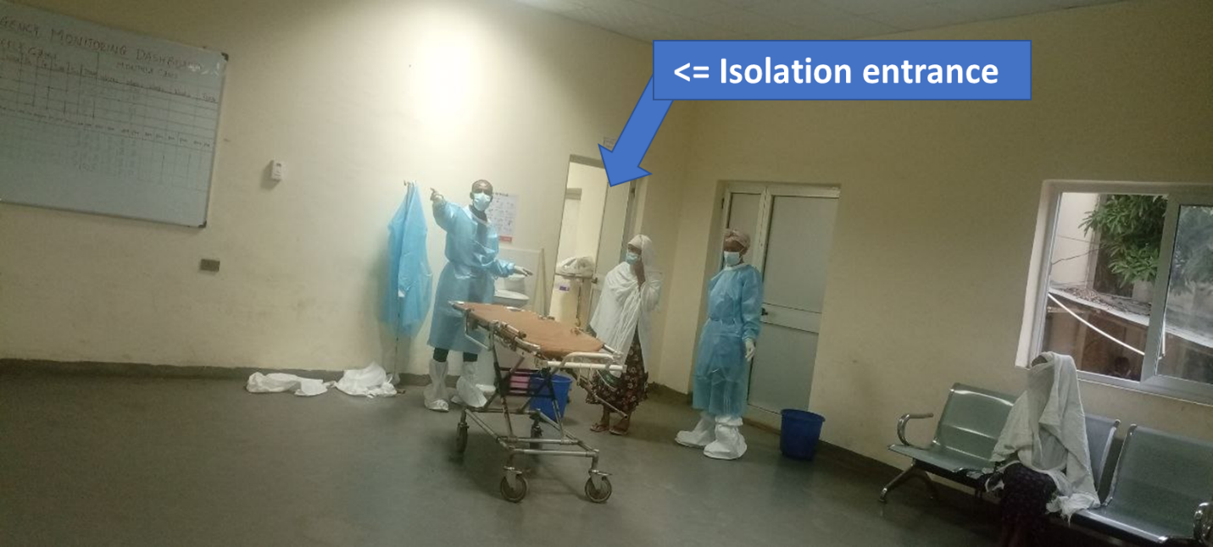
Figure 8 isolation area after the second renovation and system redesign

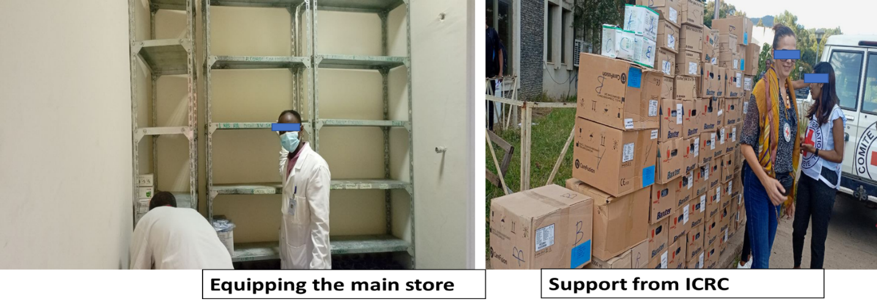
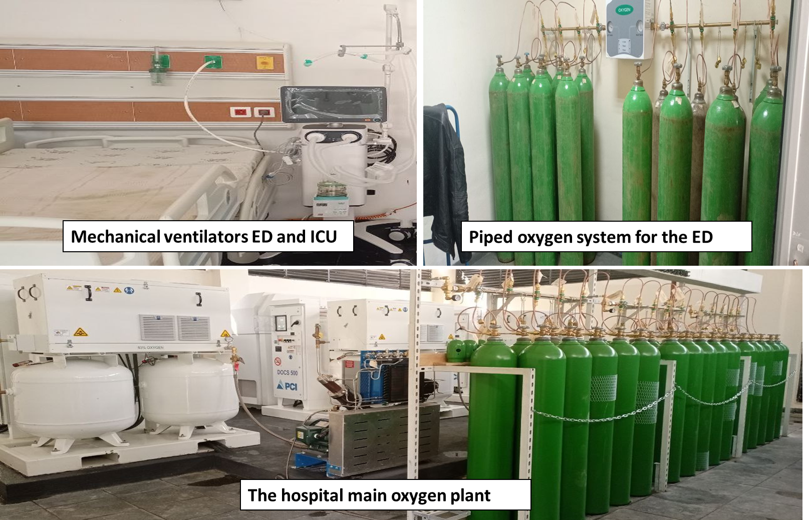
Figure 9 store area after the second renovation and system redesign and logistics

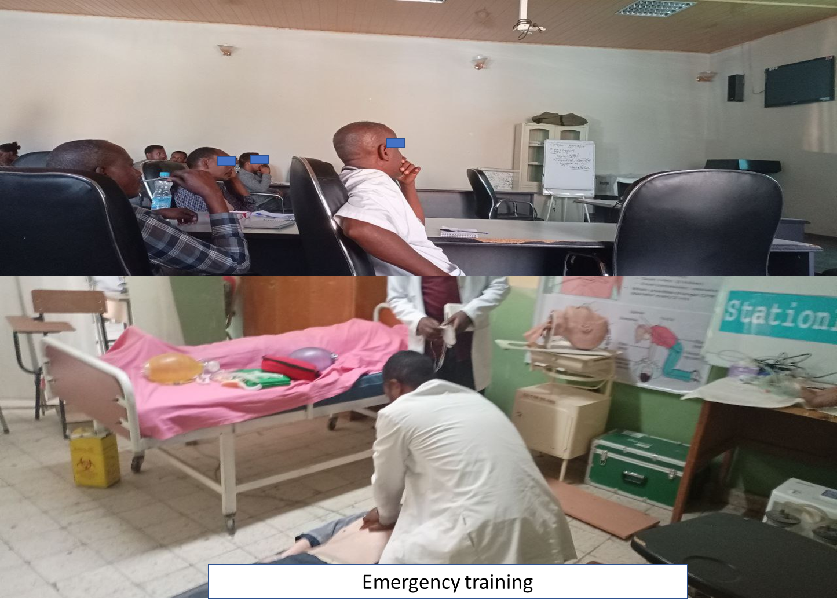
Figure 10 integrated emergency medicine training
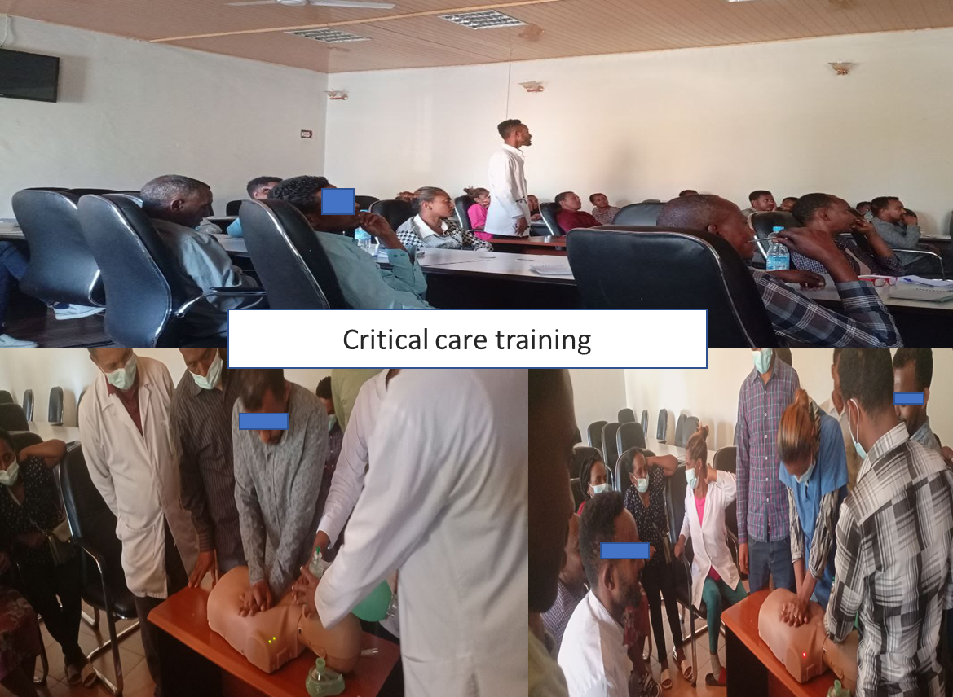
Figure 11 ICU training

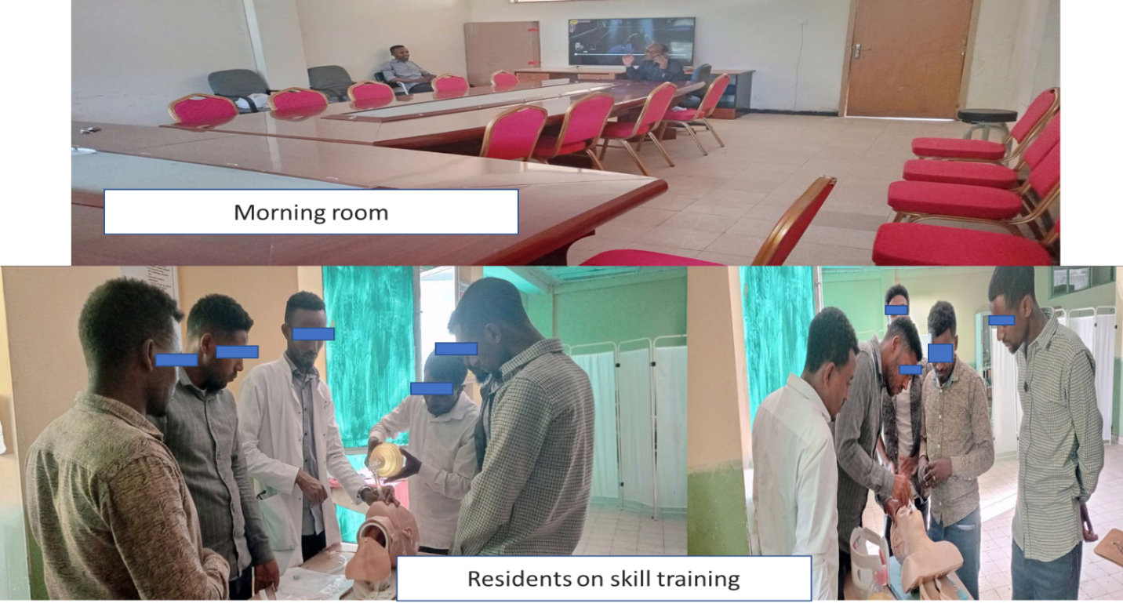
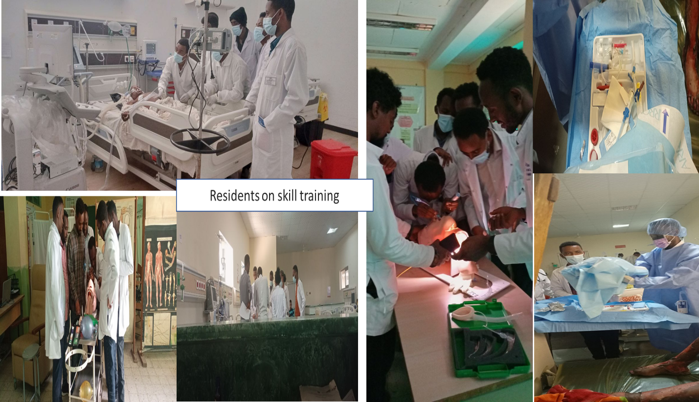
Figure 12 morning room and resident training and skill session

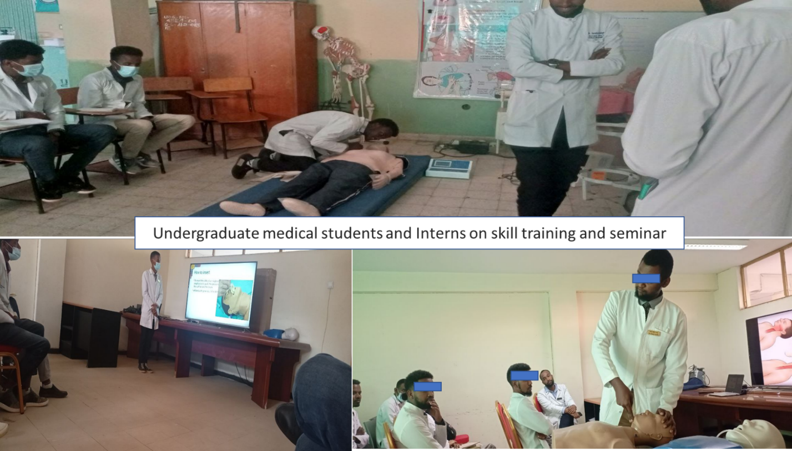
Figure 13 undergraduate medical students and intern’s seminar and skill session

